PARISH NEWS
The Deverills & Crockerton

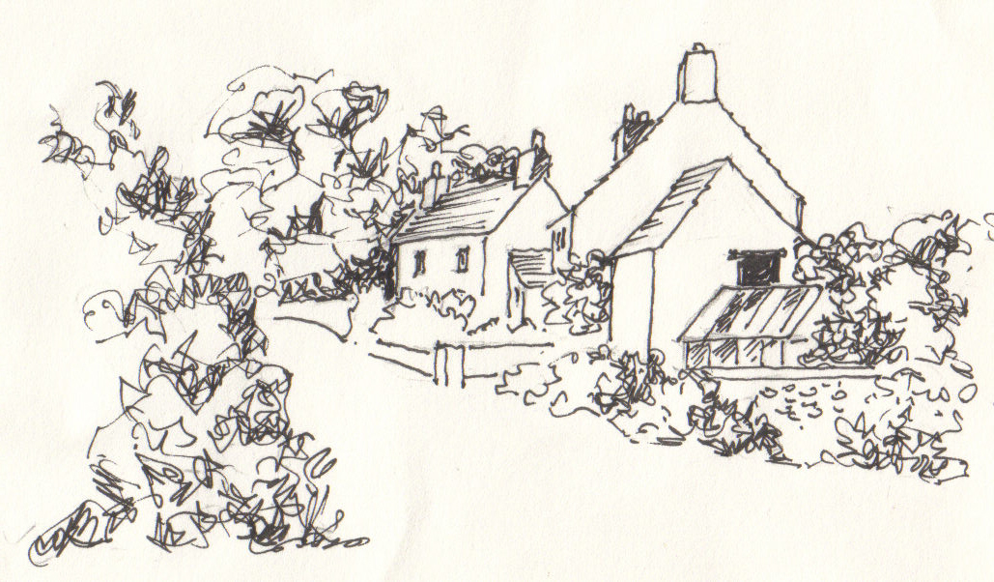

Monkton Deverill
by Pat Armstrong

May 2008

Look inside for local information

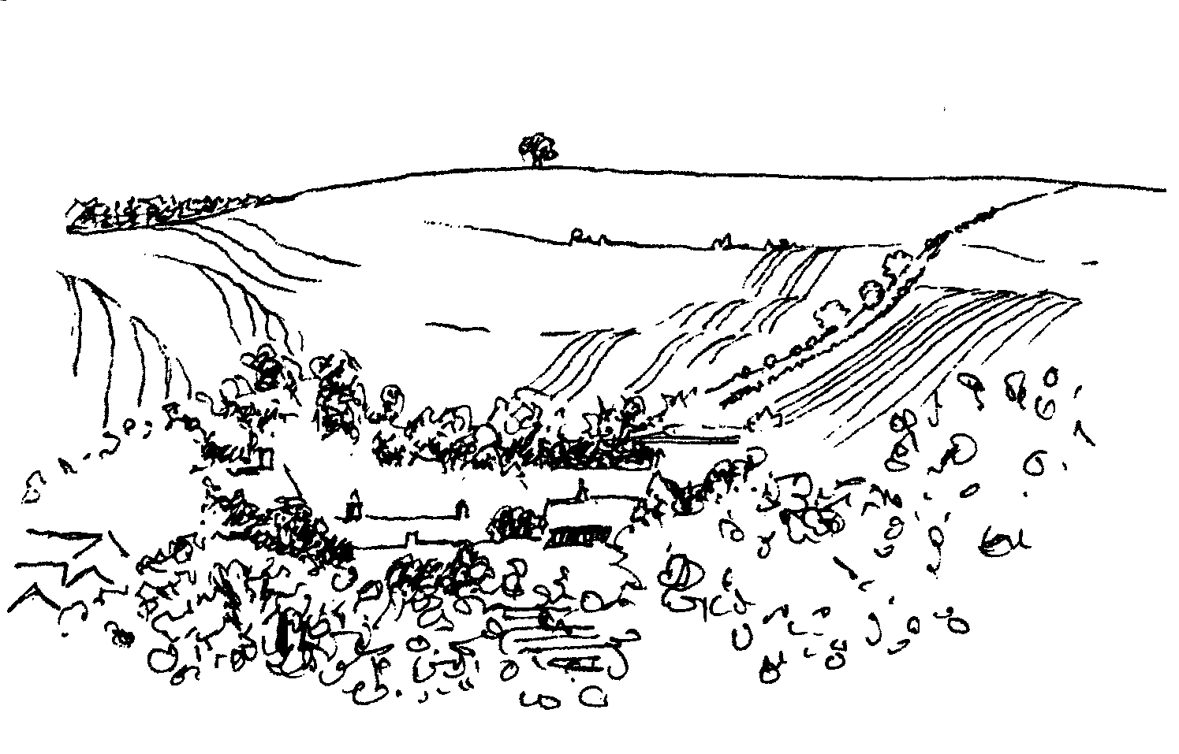
-2-

Salisbury Theatre Club Trips

Monday 19th May ‘What the Butler Saw’ by Joe Orton
Monday 16th June ‘Oliver’ by Lionel Bart
The cost is £15.00: theatre seat £10.00 and coach trip £5.00
Booking and payment in advance to Mary Stewart Cox Tel 840877
Longmead, Brixton Deverill, Warminster BA12 7EJ
Coach leaves Kingston Church 6.10 pm collects through the Deverills Performances begin at 7.30 pm

HELP for HEROES
COFFEE IN THE CONSERVATORY
Friday 23rd May
10.30 until 12 noon at Farthings, Kingston Deverill
Come for a chat and have coffee, tea and cakes in aid of this charity which helps those wounded in Britain’s current conflicts
For more information contact Trish Shuler 844291

LONGBRIDGE DEVERILL HOUSE
Fete / Garden Party on 14th June at 2.00 pm

Stalls, games, tombola, raffle and cream teas
Please join us to make this a memorable occasion for our elderly residents and their relatives and a social occasion for the village.
For more information call Jean Proctor on 214040

C R O C K E R T O N S C H O O L S U M M E R F E T E
Saturday 14th June 2.30 - 4.30 pm
Lots of children's activities including Beat the Goalie, Bouncy Castle, Father's Day Card Making (Sunday 15th June), The Stocks! Face Painting, Hair Styling and nails plus a Dance Performance, Plant Stall, Bric a Brac, Tombola, Cake Stall, Cream Teas, BBQ, Raffle with lots of fantastic prizes
from our wonderful local shops and businesses
Come and join the fun there will be something for everyone
-3-

The Rector writes:
The season of Annual Parochial Church Meetings is over; their completion is significant in the development of the Benefice of Cley Hill Villages. As we focus our attention once more on the work to which God calls us, the future looks exciting. Hopefully in the coming months, there will be opportunities to meet socially within and across our parishes. Getting to know one another is an important prerequisite for working together.
Those of you who had the pleasure of hearing the Christian Aid representative, Susan Barry, on 20th April at Chapmanslade and Kingston Deverill may recall her words. The work to which we are called begins as we leave the church building at the end of worship. As ‘living stones’ we build the kingdom of God by what we are and how we behave in the world, by our care and responsibility for the poor and the weak in particular. This is especially relevant during the month of May when we observe Christian Aid Week (11th to 16th May). By our support of the house-to-house collection red envelope campaign, we stand alongside those who depend on the education and support offered by Christian Aid across the world. Look out for details of local events during Christian Aid week on page 5 in the magazine.
There will be a further chance to get together when the CMS medical missionary, Francesca Elloway, supported by the Deverill Valley churches, is home on furlough from The Congo. She will be in the Benefice together with her diocesan bishop in June. I extend an invitation to you all to come and meet them on 17th June at Rye Hill Barn (by kind permission of Julian and Sarah Algar). We will hold a ‘Bring and Share’ Supper, details on page 4 of the magazine.
The Ordination of Diana Britten to the priesthood on Saturday 28th June in Salisbury Cathedral will offer a further chance of shared fellowship as we support Di in this next development of her ministry. The next day, Sunday 29th June please join us for worship at the Benefice Service at 10.30 am at St Margaret’s, Corsley, when Di will preside at the Eucharist for the first time. This service will be followed by a Bring-and-Share lunch to which everyone is invited.
May our shared worship and fellowship strengthen and equip us for God’s work of mission and ministry in the parishes of our Benefice and wider afield.
Norma Payne

P i a n o Q u a r t e t C o n c e r t

Kingston Deverill Church - Saturday 3rd May at 8.00 pm

Pre-concert dinner 6.30 pm in Upper Deverills Hall
Combined tickets £18.00 from Janet Budgen 218203
Concert tickets only £10.00 from Julian Wiltshire 844152
Proceeds to Deverill Valley Churches Fabric Fund

P i a n o Q u a r t e t C o n c e r t
Kingston Deverill Church - Saturday 3rd May at 8.00 pm

Pre-concert dinner 6.30 pm in Upper Deverills Hall
Combined tickets £18.00 from Janet Budgen 218203
Concert tickets only £10.00 from Julian Wiltshire 844152
Proceeds to Deverill Valley Churches Fabric Fund

-4-

Annual Parochial Church Meeting
The APCM took place at Longbridge Deverill on 30th March after a Service of Evening Prayer. Thirty parishioners attended the meeting to re-elect the churchwardens and members of the PCC. Churchwardens Elisabeth Atkinson, Nigel Poole, Mary Stewart Cox and Mike Tulloch were all re-elected unanimously. Helen Hemingway and Judy Munro, on standing down from the PCC, were replaced by general agreement with Margaret Askew and Robert Shuler. The Treasurer, David Stratton, presented the accounts which were accepted. The Deanery Synod continues to be represented by Mary Royall and John Budgen. The Chairman, Rev Norma Payne, making her report to the meeting, spoke of the smooth emergence of the Benefice of the Cley Hill Villages. She reported enthusiastically on the various avenues of her work across the parish. The Electoral Roll Officer, Mike Tulloch, was re-elected. He presented the revised Electoral Roll which showed 140 individuals on the register. The Sidespersons were also reinstated unanimously. Reports were given by Barbara Beilby (Thursday Group for Mothers and Pre-school Children), and Helen Hemingway (Fairtrade). The meeting finished socially with buffet supper provided by the ladies and wine.
Anne Honley

Bring & Share Parish Evening
To welcome Dr Francesca Elloway & Bishop Ande
Tuesday 17th June 7.00 pm for 7.30 pm
At Rye Hill Farm Barn
Tickets available in the Churches and from Churchwardens
For further information call Elisabeth Atkinson 212129
Donations towards refreshment costs will be gratefully received

Parish News - Donations and Subscriptions
Thank you to those who have already handed in your subscription for this year (£5) but just a reminder to those who have not yet done so, we would still be very grateful to receive it. If you no longer have the small blue envelope I would be very happy to provide you with another one. The envelopes can be given to me or David Stratton at Manor Farm Kingston Deverill, or put into the church collection. Donations of paper are also gratefully received either on my door step or I can pick them up from you. Both subscriptions and paper help to keep down the production costs of your Parish News.
Judy Munro - Editor 844385

-5-

Christian Aid Week 11th – 17th May
Essential Viewing:
Location, Location, Location - Bangladesh, Bolivia, Ethiopia. Poverty is rife all around the world. Too much water in some places, not enough in others. Every week, thousands of children are born into such poverty-stricken places.
Who wants to be a Millionaire? - For many people the answer is ‘I don’t.’ Having enough to feed their families once a day would suffice. One billion people live on less than $1 a day.
Neighbours - The poorest people in the world may be living thousands of miles away from us, but we all share the same planet. We’re just lucky that we happen to live further from the equator.
A Place in the Sun - When you’ve no choice but to cut down the local trees to sell as firewood so that your children can eat, you’re exposed to a lot of sun. And what happens when it rains? No shelter from that either. There’s no hiding from any of the elements.
Casualty - Dengue fever, typhoid and HIV are all spread by poverty, not just people. The yearly casualties from these diseases shame the western world.
The News - £15 million doesn’t just collect itself. Quite simply, Christian Aid needs you. The money collected in Christian Aid Week helps make change possible: from emergency work to gender education and the provision of essential health services.
Extraordinary people - Needed to help with the house to house collection in Longbridge Deverill, Hill Deverill and Crockerton. Please contact Rev Norma Payne on 841321.
Britain’s Rich List Giving it Away - If you have food in your fridge and loose change in your pocket you belong to a minority group – you are one of the richest people in the world. Please give generously in Christian Aid Week. If you do not receive an envelope through your letterbox you can pick one up at any of the Deverills’ churches; send a cheque payable to Christian Aid to Christian Aid, FREEPOST (no postcode required); donate using your mobile phone by texting CAWEEK1 to 84880; donate online at www.caweek.org.
Masterminds - Teams of four invited to put their brains to the test in Quizaid, an entertaining new way of raising money for Christian Aid, on Friday 16th May at 7.30pm, at Longbridge Deverill Village Hall. Tickets/Entry £5 per person to include a simple Ploughman’s Supper. Please bring own liquid refreshment – glasses provided.
Adapted from the Christian Aid News, Spring 2008. Submitted by Helen Hemingway, co-ordinator for Christian Aid Week collections, Upper Deverills.
Free Rice Website
This is a free English vocabulary online word game at www.freerice.com and by playing the result is free rice going to help hungry people. It is endorsed by the UN World Food Program and made possible by sponsors advertising on the site. Have some fun and you will be helping to alleviate world hunger.

-6-
Pilgrimage 2008
For two weeks in April over 40 travellers, of varying levels of Christian commitment, undertook a Journey to the Dawn of Faith – a pilgrimage in Turkey. Starting in Istanbul, with its iconic mosques and churches, and reaching out to Cappadocia (churches and whole communities built into the limestone hills), we traced the biblical hotspots of Konya (Iconium – famous for the Whirling Dervishes), Yalvac (Antioch in Pisidia visited by Paul and Barnabas), Hierapolis with its calcium pools, Laodicea (one of John’s seven churches) and Miletus (scene of Paul’s emotional farewell to the Ephesus elders). Then it was breath-taking Ephesus itself. Whereas only 40% of this third city of the Roman Empire has been excavated, the streets, houses, public buildings and theatres could have been built yesterday. Efficiently and sensitively led by Richard and Margaret Askew, with two colleagues, we all came away with a deep sense of history – Turkey really was the cradle of Christianity – and spiritual enlightenment. Sait, our local guide, expertly introduced us to Turkish current affairs, culture, history ... and humour! With over 1,200 miles travelled (some by air!) and six hotels, the fortnight was exhausting but so stimulating. I can thoroughly recommend that you think of going with Richard and Margaret next year to Italy.
Richard Munro
New Zealand Excitement
Just a brief note to thank all those of you who were kind enough to keep me and Jane in your prayers during our recent problems in New Zealand. The aortic aneurysm, which burst, was pretty frightening, but the treatment that I received in NZ was wonderful. I was told afterwards that only 5% of people to whom that happens recover - the vast majority never get to the operating table, so I can count myself very lucky. I think God must have something left for me to do, I am not yet sure what, but no doubt he will let me know in due course! The op has left me with a non-functional right leg which means using crutches and a wheelchair. The prognosis is about 50/50 that it will recover but we shan't know for 2 years!
We were very uplifted knowing that there were so many people praying for a recovery over here in UK, to be 12,000 miles away when that sort of thing happens is not easy. Thank you for all who sent cards and messages, Chris Rodgers was marvellous sending progress e-mails which I gather were quite wide spread! If anyone feels like coming to visit, I would be glad to see you, just ring first on 844374 to see that I am going to be here and your visit doesn't clash with someone else. Once again, very many thanks for all your love and prayers and your messages of love and support to Jane. I know they had a huge influence on my recovery.
Richard Yates

-7-

Deverill Valley & Crockerton Women's Institute
Prior to our monthly meeting there will be a Group meeting on Thursday 8th May at Sutton Veny when the subject will be the ‘Mary Rose’. Then on Monday 12th May we will have our usual meeting at 7.30 pm in Longbridge Deverill Village Hall. Our Resolution discussion will be ‘Inappropriate imprisonment of the mentally ill’. Then a social time with Sheila Hopkinson who will be telling us about The Great Wall of China. This meeting is open to the public so come and join us, you will be very welcome. Refreshments will be served. Please contact Ann Dufosee 840360 for more information.
Longbridge Deverill Village Hall
Longbridge Deverill Race Night
Many thanks to the Lions for organizing the Race night which was a great success. Many of us found out it was not as easy as it looked to race the horses! I don't think anyone ‘lost their shirt’, but the Lions and the Hall profited nicely - thank you to all who took part. The fish and chip supper was a very welcome break in the excitement!

Table Top Sale
Saturday 17th May 10.00 am –12.00 noon
To book a table @ £5.00 please call Sylvia Titt 214825, refreshments on sale.
Future Events
Saturday 4th October Harvest Supper, November - Quiz Night
Jo Nelson 840784
Upper Deverills Village Hall
Annual Rounders Evening Friday 13th June
Our traditional Upper Deverills Rounders Evening begins at 6.00 pm. The first match will start at 6.30pm. There will be a barbecue and a barrel of beer so it is an evening not to miss. Sporting skills are not necessary so bring the family to one of the most enjoyable Village Hall events of the summer.
Future Events
Saturday 5th July Duck Race, Saturday 19th July Summer Fete
Richard Cousens 844970
Cream Teas and Open Garden in aid of Save the Children
To be held at Mill Farm House, Hill Deverill on Sunday 25th May (and on the last Sunday of the following four months). Cakes and plants will be for sale with other interesting items. Enjoy a relaxing afternoon in the barn or garden.
The Barn Dance held at Mill Farm House, Hill Deverill in March raised £1,040 for the Save the Children Fund. It was a lovely evening, enjoyed by everyone. Thank you to Val Dale and family for their hospitality, the White Horse Band for their lively music, the committee for the delicious supper and to all who supported the event.
Anne Hurd

-8-
SERVICES PARISH OF DEVERILLS & HORNINGSHAM

Sunday 7th after Easter
4th May Brixton - 8.00 am Holy Communion 1662
Canon Richard Askew
Longbridge - 10.30 am Morning Worship
Rev Di Britten
Horningsham - 6.30 pm Rogation Service Parsonage Farm
Rev Norma Payne
Sunday Pentecost
11th May Kingston - 10.30 am Holy Communion
Canon Richard Askew
Horningsham - 11.15 am Holy Communion 1662
Rev Norma Payne
Friday
16th May Longbridge - 2.00 pm Pre-school Praise
Rev Norma Payne
Sunday Trinity
18th May Longbridge - 8.00 am Holy Communion 1662
Rev John Goodden
Brixton - 10.30 am Holy Communion
Rev Norma Payne
Sunday 1st after Trinity
25th May Longbridge - 10.30 am Holy Communion
Rev Norma Payne
Horningsham - 11.15 am Morning Prayer
Col Robin Chappell
Kingston - 6.00 pm Evening Prayer
Mr John Budgen

Sunday 2nd after Trinity
1st June Kingston - 8.00 am Holy Communion 1662
Longbridge - 10.30 am Morning Worship

Tuesday, Wednesday, Thursday, Friday Longbridge 8.30 am Morning Prayer
Wednesday Longbridge 10.15 am Holy Communion

Brixton Church
Thankfully the restoration work is now complete so our services can now resume

THE DEVERILLS REGISTER
Funeral Service at Longbridge Deverill
For Gordon George Phelps on Friday 18th April

-9-

SERVICES PARISH OF CORSLEY & CHAPMANSLADE

Sunday 7th after Easter
4th May Chapmanslade - 9.00 am Family Communion
Rev Alison Wadsworth
Sunday Pentecost
11th May Corsley - 9.00 am Holy Communion
Rev Norma Payne
Temple - 11.00 am Morning Prayer
Rev Di Britten
Sunday Trinity
18th May Chapmanslade - 9.00 am Family Communion Rev Norma Payne
Corsley - 6.00 pm Evening Worship
Rev Di Britten
Sunday 1st after Trinity
25th May Temple - 9.00 am Holy Communion 1662
Rev Norma Payne
Corsley - 10.30 am Parish Service
Rev Di Britten
Sunday 2nd after Trinity
1st June Corsley - 9.00 am Holy Communion
Chapmanslade - 4.00 pm Tea Service

Grandmothers
A grandmother is a lady who has no children of her own, so she likes other people’s little boys and girls. A grandfather is a man grandmother. He goes for long walks with the boys and they talk about fishing and tractors. Grandmothers don’t have to do anything but be there. They are old so they shouldn’t play hard or have fun. They never say ‘hurry up’. Usually they are fat, but not too fat to tie children’s shoes. They wear glasses and funny underwear, and they can take their teeth and gums off. The don’t have to be smart, only answer questions like why dogs hate cats and why God isn’t married. They don’t talk baby talk like visitors. When they read to us, they don’t skip bits, or mind if it is the same story over again. Everybody should have one, especially if you don’t have television, because grandmothers are the only grown-ups who have time. (Essay by 8-year-old)
This is from a sermon by Richard Askew repeated by popular request!
The Senility Prayer
Grant me the senility to forget the people I never liked anyway, the good fortune to run into the ones I do, and the eyesight to tell the difference.

-10-

Ivy House St Denys Retreat Centre
Thursday 1st May
Ascension Quiet Day with Canon Alan Gill
For more information please phone 214824

Church Cleaners for May
Kingston - Mrs Fagan & Mrs Munro
Brixton - Mrs Armstrong & Mrs Burridge
Longbridge - Monday 12th May 9.30 - 10.30 am - all helpers

Church Flower Arrangers for January
Kingston Brixton Longbridge
4th May Mrs Askew Mrs McDonald Mrs Atkinson
11th May Mrs Askew Mrs Lawson Mrs Atkinson
18th May Mrs Gatt Mrs Lawson Mrs Birts
25th May Mrs Gatt Mrs Greenwood Mrs Birts

CONTACT THE EDITOR AND WEBSITE
Parish News Editor - Judy Munro 844385
Contributions for the Parish News through my letterbox or
by post to Whitepits Lodge, Kingston Deverill, Warminster,
BA12 7HD or by Email: judymunro@tiscali.co.uk Thank you
Please remember the deadline is the 15th of every month

Website: www.deverills.org.uk Email address:info@deverills.org.uk
Website manager : Kate Wilkinson 844998
Contents: Parish News with church services, Parish Register, Events, Local News plus pictures and other information
Contact the Clergy
Please contact Norma Payne (841321) or Di Britten (01373 832515) if anyone is housebound and would like communion or a visit at home; or if someone is ill and needs our prayers; or to discuss any church matter.
Office administrator phone 210149 or email: office@cleyhill-team.org.uk

-11-

Sir James Thynne House - Longbridge Deverill
ACCOMMODATION AVAILABLE
Comfortable ground-floor flat: bed-sitting room, kitchen, bathroom, garden area. For single occupancy. Applicants should be not less than 50 years old, with preference given to those who are resident in the areas of The Deverills, Crockerton, Horningsham and Sutton Veny. Please contact Sue Jackson 840322.

Upper Deverills Parish Council
The Annual Parish Meeting will be held on Wednesday 14th May at 7.00 pm in the Upper Deverills Village Hall. This is an opportunity to hear about what has been going on over the past year from local organisations, such as the Parish Council, Village Hall Committee, Parochial Church Council, Neighbourhood Watch, etc. This meeting will be followed immediately by the Annual Council Meeting. All are welcome.
News from Warminster Police
The Community Contact Point (CCP) will be open at Warminster Police Station every Wednesday from 10.00 am to 1.00 pm. This will provide an opportunity to talk to Police and Police Community Support Officers about a variety of policing issues. Entrance is via the front door in Station Road. Unfortunately officers staffing the Contact point will not be able to deal with production of driving documents or with reports of vehicle collisions. These must continue to be reported to the Force Contact Centre on 0845 408 7000 or your nearest open Enquiry Office (Melksham or Salisbury). The CCP will be staffed by members of the Town and Rural Neighbourhood Policing teams who will be happy to advise on issues such as anti social behaviour, community problems and crime prevention. The Warminster Neighbourhood Policing teams are contactable on 0845 408 7000 or via Wiltshire & Swindon Intelligence Network on the internet outside these opening hours.
New Painting Group in Crockerton
I am starting a new painting group in Crockerton, from the studio in my home, at Heather Mount, Potters Hill. It will take place on Wednesdays starting on 7th May. All levels of artists are invited to join, and for beginners, help, advice and encouragement will be readily available. Studio equipment will be provided, so people only have to bring their own choice of paints and paper etc. (advice available if needed). I am hoping to form a group where people can meet others to enjoy their love of art, experiment a bit without being afraid of making mistakes, and most importantly - to be inspired. I'm also hoping to arrange for an occasional model, trips to art galleries and a little 'plein air' painting. I am also arranging separately a Watercolour Workshop in May with Jake Winkle who writes for the Artist magazine. So, if you would like more information on dates, times and prices, please phone me.
Pamela Johnson 847562

-12-

Frome wants to know what you think of it!
As part of a big consultation with residents and users of Frome, a community group called ‘Vision for Frome’ is asking the surrounding rural areas to say what it means to them. So if you sometimes use the town and feel that there is room for improvement please let them know. (Similarly, if you think something is wonderful, pass that on.) Either tell them in the Info Point at the George or write to: Vision for Frome c/o The George Hotel, Market Place Frome BA11 1AE, or by email: ourfrome@yahoo.co.uk All comments thankfully received.
Maggy Daniell

Parish Guide - Where have you been?
Castle Garden Centre, Sherborne, Dorset
This month’s ‘Where have you been?’ submitted by Daphne Woodcock from Longbridge Deverill, is so beautifully written I have merely quoted it in its entirety.
It is that time of year again and the garden is calling out for attention. The garden centre near the old castle in Sherborne is worth a visit – not cheap but with a huge range of good quality plants. Make sure you visit around lunchtime. The little café there is super; everything is cooked to order – and you can reserve a table. We had a delicious omelette which came with salad and new potatoes – very reasonably priced. Sherborne itself is well worth exploring with its abbey and enticing shops, well worth a visit.
I am grateful to Daphne for taking the trouble to pass this on to me and I would be very happy to receive contributions from other readers. I am sure that many of you go out and about quite a bit, so please share your experiences with the readers of this magazine!
Please send your contributions to me through my door at Farthings, Kingston Deverill or by email at farthings.kd@btinternet.com
Trish Shuler 844291
Compensation for Jordanian Farmers.
Recently I returned from Jordan, a kingdom that has just experienced a harsh late frost/snow, the worst for a decade. Many farmers have lost entire crops of fruit and vegetable in the Jordan Valley. It was reported by Jordanian Times that 5,000 farmers will be entitled to compensation and already the Agricultural Ministry have allocated JD10m (£13.5m). Names of farmers who have suffered more than 30% losses were obtained by the Finance Ministry on Sunday 18th February and compensation was paid the following week. How different are our own farmers’ experiences regarding DEFRA payouts.
Les Wood

-13-

The First Swallows
Sylvia Titt has reported to the Parish News that she saw the first swallows in the Parish at Longbridge Deverill Church on the 1st of April.

Bird Notes
April is living up to its ‘sunshine and showers’ reputation, but quite often they’ve been of snow, or sleet or hail. This April couldn’t have been more different from the one we had last year. The summer migrants must be wondering why they’ve flown all the way here!
I saw my first swallow on the 2nd April flying over the hills above Boyton. We first saw a swallow here at the farm on the 5th, but we think it travelled on. ‘Our’ swallows started to arrive on the 11th April; one was sitting on the wire above the vegetable patch chattering away to itself. A week later we had 3 swallows flying around together. So far no house martins have arrived back. When they do they will find that the nests will need extensive repairs as the winter winds and rain have damaged them.
I have seen and heard some other summer migrants. I heard my first cuckoo on the 13th April in the woods at the top of the farm. I spotted a male blackcap in the garden on the 1st April, but it was nearly two weeks later before it started singing well. I have heard and seen chiffchaffs but as yet no whitethroats, willow warblers or wood warblers. I think this colder weather we’ve been having has certainly affected migration and breeding. I don’t think the birds are singing quite as much as they would normally be doing at this time of the year. A few warmer days would soon change things.
We’ve had good numbers of yellowhammers up on the farm. These birds are resident all year round. The males are easily spotted with their lemon yellow heads which are particularly bright now that they are in breeding plumage. We had a pair of bullfinches in the garden on the 11th April and the male was very smart once again in his breeding plumage. Other birds I have spotted on the farm include two male redstarts and a pair of wheatears, both summer migrants and en route to their breeding grounds, probably a Welsh wood in the case of the redstarts and an upland area for the wheatears. I’d not seen redstarts here before. Down at Shearwater I’ve seen a sandpiper, common one I think, and a tern, again I think common, both summer migrants.
Look out for the swifts arriving. I usually see them first in town at the beginning of May. I love hearing them scream as they chase one another around the buildings. For me they are a true sign that summer is just around the corner.
Jane Trollope

-14-

LOCAL COUNCILS, SOCIETIES, GROUPS etc.

Longbridge and Crockerton Parish Council
Bill Hurd 840023 (Chair) Tom Minter 216909
Michael Aplin 840684 (Clerk) Elaine Pidgeon 212878
Julian Algar 840816 Graham Read 840296
Karen Manfield 215526 Peter Whithey 840347
Brian Marshall 214789

Upper Deverills Parish Council
Lady Felicity Wheeler 844683 (Chair) Ranald Blue 841374
Jacqueline Smith 840238 (Clerk) Patricia Shuler 844291

District Councillor
Shear Water Ward - Michael Mounde 844363
Longbridge Deverill Village Hall Committee
Jo Nelson 840784 (Chair)
Barbara Smith 840251 (Secretary) Sylvia Titt 214825 (Caretaker)
Upper Deverills Village Hall
Richard Cousens 844970 (Chair)
Mandy Martyn 844320 (Secretary) John Lea 844325 (Hall bookings)
Crockerton Millennium Committee
Marion Thomas 213739 (Chair)
Pre-School Children and Parents ‘Thursday Group’
Barbara Beilby 844995 (Chair) Sylvia Titt 214825 (Leader)
Deverill Valley & Crockerton W I
Ruth Sutton (President) Jill Russell 840209 (Secretary)
Sir James Thynne Almshouse
Mrs Sue Jackson 840322 (Steward)

Deverills Cricket Club
Jamie Fagan 844123 Peter Child 01963 34593

Wylye Valley Tennis Club
Colin Singer 213696
Wylye Valley Flower Club
Mrs Hazel Yate 215617 (President) Mrs S Scott 213689 (Programme Secretary)
Wiltshire Wildlife Trust
www.wiltshirewildlife.org
Elm Tree Court, Long Street, Devizes SN10 1NJ
Rural Community Beat Officer - Neighbourhood Watch
PC Phil Bridge 0845 408 7000

-15-

FORTHCOMING EVENTS

- Hearing Loss Lip-reading Wednesdays Margaret Head (213259)
- Scottish Dancing Monday Evenings Aline Fry (841054)
- Badminton Mondays & Fridays 3.00 - 5.00 pm Alison Rymell (844819)
- Pre-school & Parents Group Thursdays 10.00 - 11.30 am See p14
- Ivy House Ascension Quiet Day Thursday 1st May See p10
- Concert St Mary's Kingston Deverill Saturday 3rd May See p3
- Wylye Valley Flower Club Plant Sale Saturday 3rd May See p14
- Crockerton Painting Group Wednesday 7th May See p11
- Women’s Institute Group Meeting Thursday 8th May See p7
- Christian Aid Week 11th - 17th May See p5
- Women’s Institute ‘Great Wall of China’ Monday 12th May See p7
- Wylye Valley Flower Club Arrange a Rainbow Tuesday 13th May See p14
- Upper Deverills Parish Council Meeting Wednesday 14th May See p11
- Quizaid Friday 16th May See p5
- Table Top Sale Saturday 17th May See p7
- Salisbury Theatre Club Monday 19th May See p2
- Help for Heroes Coffee Morning Friday 23rd May See p2
- Save the Children Teas Sunday 25th May See p7
- Rounders Evening Friday 13th June See p7
- Crockerton School Summer Fete Saturday 14th June See p2
- Longbridge Deverill House Summer Fete Saturday 14th June See p2
- Salisbury Theatre Club Monday 16th June See p2
- Bring & Share Parish Evening Tuesday 17th June See p4
- Crockerton Millennium Committee Mid Summer Party Saturday 21st June
- Ordination of Di Britten Saturday 28th June See p3
- Benefice Service Bring & Share Lunch Sunday 29th June See p3
- Save the Children Teas Sunday 29th June See p7
- Duck Race Saturday 5th July See p7
- Upper Deverills Summer Fete Saturday 19th July See p7

-16-

PARISH OF THE DEVERILLS
Churches
SS Peter & Paul the Apostles Longbridge Deverill
St Michael the Archangel Brixton Deverill
St Mary the Virgin Kingston Deverill
St John the Baptist Horningsham
Rector
Rev Norma Payne, 6 Homefields, Longbridge Deverill 841321
Clergy
Rev Diana Britten, 69 Lane End, Corsley 01373 832515
Licensed Lay Ministers
Mr John Budgen, Woodlands, Sutton End, Crockerton 218203
Col Robin Chappell, 7 Elm Hill, Warminster 212153
Churchwardens
Mrs Elisabeth Atkinson, 133 Foxholes, Crockerton 212129
Mr Nigel Poole, 7 Homefields, Longbridge Deverill 840902
Mrs Mary Stewart Cox, Longmead, Brixton Deverill 840877
Major Mike Tulloch, Spring Cottage, Monkton Deverill 844381
Lay Pastoral Assistant Co-ordinator
Rev Norma Payne, 6 Homefields, Longbridge Deverill 84l321
PCC Treasurer
Mr David Stratton, Manor Farm, Kingston Deverill 844549
PCC Secretary
Mrs Anne Honley, Dry Hill House, Crockerton 215956
Church Electoral Roll Officer
Major Mike Tulloch, Spring Cottage, Monkton Deverill 844381
Parish News Editor
Mrs Judy Munro, Whitepits Lodge, Kingston Deverill 844385
Organist
Mr John Budgen, Woodlands, Sutton End, Crockerton 218203
Tower Captain
Mr Stephen Young, 68 Highbury Park, Warminster 212796
Caretaker - Longbridge Church
Mrs Sylvia Titt, 7 Church Street, Longbridge Deverill 214825
Office Administrator (Mon-Fri 10.00 - 12.00)
Mr Dick Collins, 22 Church Street, Warminster 210149

